**Unix/Linux for Testers**

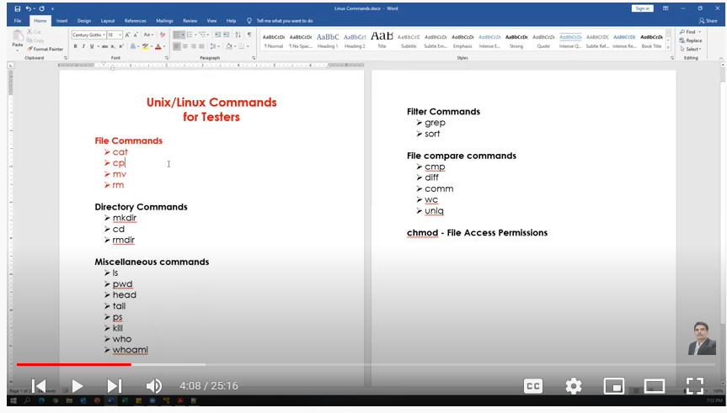

**Miscellaneous commands:**

(i) "Clear" is the command to clear the screen in Linux not *cls.*

**File Commands:**

**cat**

Creating the new file

Display content of the file

Concatenating more than one file

Appending data to the existing file

cp - Copy contents from a file to another file(source to destination)

mv

Renaming a file(changing name of the file)

Renaming a directory

Moves files from one directory to another directory

rm - Delete/remove a file or directory (only if directory is empty).

Note: (i) we can also create file using "touch" command. Difference between "cat" vs "touch".

(ii) File can be edited using "Vim" editor.

cat

cat >testing.txt # to create file

manual testing

automation testing

(ctrl+d) for exit

cat testing.txt # for display

cat yourdirecory/automation.txt # to display anything inside directory

cat testing.txt testing123.txt # for concatenate

cat >>testing.txt # for amend

cp

cp testing.txt testing_new.txt

# Copy contents from a file to another file(source to destination)

mv

mv testing.txt automation.txt # re-name a file

mv mydir yourdir # re-name a directory

mv automation.txt yourdir # moving a directory

rm

rm testing.txt # to delete a file

rm "directory name" # to delete a directory when it's empty

rm -r "directory name" # to delete a directory forcefully when some files in it

" -r" is used for recursive.

Note: we can also use "rmdir" command to delete a directory if it is empty

**Directory Commands**

mkdir - create directories and subdirectories.

mkdir testdir

create multiple directories at one time:

mkdir testdir1 testdir2 testdir3

create several subdirectories at one time:

mkdir -p world/countries/states

-------------------------------------------------------------------

cd - changing/closing directory

cd .. : go back to one level

cd /testdir1/testdir2/testdir3 → changing directory

pwd : it prints present directory

cd ~ Move to users home directory from anywhere.

------------------------------------------------------------------

rmdir - Remove the directory if it is empty (works only if directory empty)

rmdir world // error (because "world" directory is not empty)

** In this case we can use **"rm -r"** command

rm -r world

rmdir testdir1 testdir2 testdir3

**touch, pwd & ls Commands**

touch - to create a file

touch myfile.doc

touch /myhiddenfile.txt #to create a hidden file

---------------------------------------------------------------------------------------------------------------------------

ls : List Files

ls -l : (long list) shows file or directory, size, modified date and time, file or folder name and owner of file and its permission.

ls -a : view hidden files

touch .myfile.txt

ls -a

ls -l -a : detailed listing files along with hiddwn files

ls -F : will add the ‘/’ Character at the end each directory.

ls -r : display files and directories in reverse order.

ls -R : displays directories along with sub subdirectories

ls -lS : ("S" in upper case) displays file size in order, will display big in size first.

ls -l Documents : list files under directory Documents.

(I need to check this command in detail in future)

wild card characters

------------------------------

? Single character

* Multiple characters

[ ] Range of values

ls ?.*

Output: a.doc b.doc c.doc x.txt y.txt

ls ?.doc

Output: a.doc b.doc c.doc

ls ?.txt

Output: x.txt y.txt

ls a* Displays files which are starting with 'a'

Output: abc.doc a.doc

Range(Displays files starting with a to z)

--------------------------------------------------------

ls [a-z]*.*

Output:



ls [a-c]*.*

Output:



ls [a-z]*.txt

**head, tail, more & less Commands**

**Note:** Instead of "cat" command we have these following commands for display.

**head :** to display specified number of lines from top of the file.

--------

**head cities.txt**

* Display 10 lines from top of the file.

* 10 is the default value for head command

**head -n 15 cities.txt** (or) **head -15 cities.txt** # will show first 15 lines of the text

**head -n 5 cities.txt** # will show first 5 lines of the text

**tail** : to display specified number of lines from bottom of the file.

----------------

**tail cities.txt**

* Display last 10 lines from the file.

* 10 is the default value for tail command

**tail -n 15 cities.txt** (or) **tail -15 cities.txt** # will show last 15 lines of the text

**tail -n 5 cities.txt** # will show last 5 lines of the text

Display the lines from 10 to 15

**head -15 cities.txt | tail -6**

Display the lines from 20 to 30

**head -30 cities.txt | tail -11**

**ls - l** Display List of files and directories

**ls -l | head -5** Display Top 5 files and directories

**ls -l | tail -5** Display Top 5 files and directories

**more :** Display content page by page. **Forward directional**. Can't go to the previous page.

(Next page: press "space bar", Next line: press "Enter" button, Exit: press "q" button)

**more cities.txt**

**less** : Display content page by page in **both directions** means *next page or to previous page.*

(Next page: press "space bar", Next line: press "Enter" button, Exit: press "q" button)

(Previous Page: Press upper key "↑")

**less cities.txt**

-----------------------------------------------------------

**ls -l | more**

**ls -l | less**